


NauticEd and SailTies Partner to Authenticate Sailing Logbooks with GPS Tracking and Sharing
Authenticated Logbooks Revolutionize Boating Resumes
while Giving Social Sharing Capabilities

AUSTIN, Texas – February 28, 2023 – NauticEd, the world’s leading sailing education provider, has announced a partnership with SailTies, the popular sailing voyage GPS tracking and sharing app. Users of both platforms can now choose to link their accounts to enjoy integrated features of the connected platforms.

NauticEd and SailTies directors Grant Headifen and Chris Jacobs penciled the tech alliance out on a bar napkin in Zagreb, Croatia – while brainstorming solutions to the industry-wide problem of validating a boater’s experience. The pair were attending the International Charter Expo (ICE), the annual B2B expo where charter industry leaders meet. The integration of SailTies GPS tracking data with NauticEd's logbook and resume tools provides users with a powerful tool, and the GPS-authenticated experience gives charter companies increased confidence in prospective customers.

Nauticed users can now use the SailTies app’s GPS tracking to build and authenticate their electronic logbook for their sailing voyages. Voyages recorded by SailTies are automatically uploaded to their NauticEd electronic logbook as an authenticated experience. This information is then applied to a boating resume that includes the user's boating experience, completed educational courses, and professional instructor on-the-water assessments. With SailTies, the resume now also includes a "% of logbook authenticated by GPS" value, which adds credibility to the boating resume.

Using SailTies’ sharing features, NauticEd users also can now share the voyage GPS tracks with friends and crew. Once invited, crew members can add their photos of the venture along the GPS track, memorializing the experience.

SailTies users gain access to NauticEd’s world-class sailing and boating education platform, which includes NauticEd’s electronic logbook and sailing resume building tools. The integration between SailTies and NauticEd allows users to effortlessly add their voyage experience to a resume that is recognized by boat charter companies worldwide. Furthermore, SailTies users can apply their recorded experience towards sailing certification qualifications, such as the SLC (International Sailing License and Credentials).

"The integration of GPS tracking into the logbook is a game-changer for boating resumes," according to Grant Headifen, Global Director of Education at NauticEd. "For years, boat rental companies have struggled with the authenticity of a potential renter’s experience. Since the agreement to rent a boat is based on the real on-the-water experience of the boater, an accurate representation of experience is especially valuable for boat rental companies. This NauticEd-SailTies connection provides a revolutionary credible way for boat rental companies to assess the competency of their clients."

“The data connection is seamless”, says SailTies co-founder, Chris Jacobs who set up the API connection between the two companies. “NauticEd students simply download the iOS or Android version of the SailTies App, click on a button in their NauticEd online logbook, then the accounts are linked! GPS tracks on SailTies appear as authenticated entries into the NauticEd user’s logbook."

Jacobs is excited to see NauticEd's vast client base recording their time at sea on the SailTies App. Headifen says that he enjoys adding additional powerful tools and benefits to the NauticEd platform for its students.

Both the SailTies App (available at sailties.net, Apple Apple Store, and Google Play) and NauticEd’s resume-building platform (available at nauticed.org) are free. Users can pay for optional extras such as eLearning theory courses and on-the-water training by NauticEd or premium upgrades via SailTies.

About NauticEd
NauticEd is a fully recognized education and certification platform for sailing students combining online and on-the-water real instruction, and more recently - Virtual Reality. Since Grant Headifen founded NauticEd in 2008, students have taken over a quarter million sailing courses from its e-learning platform combined with on-the-water experience via sailing partners and schools in 23 countries. NauticEd offers 24 online courses, an electronic logbook, a sailing resume-building tool, and six ranks of certification – all integrated into NauticEd’s proprietary platform. The U.S. Coast Guard and the National Association of State Boating Law Administrators (NASBLA) recognize NauticEd as having met the established American National Standards for sail training thus establishing NauticEd as a world-class leader in sailing training, certification, and global boating licensing. For more information, please visit www.nauticed.org

About SailTies
Started in the UK in 2019, SailTies is on a mission to create the best way to capture all your sailing in one place. SailTies is a small team of developers and designers, with a passion for sailing. The app has innovative tracking and sharing tools and a community of passionate sailors. For more information, please visit www.sailties.net.

# # #
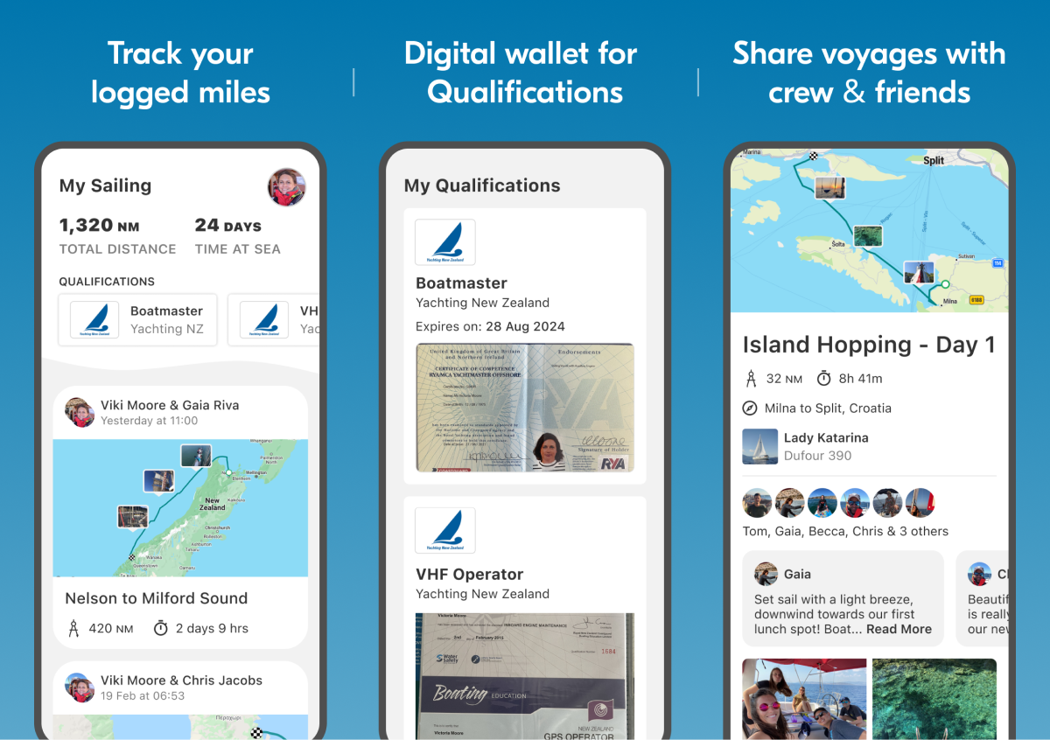
Photo Caption: NauticEd and SailTies collaborate to Authenticate Sailing Logbooks with GPS Tracking and Sharing. SailTies makes it simple to capture, relive, and share your sailing.

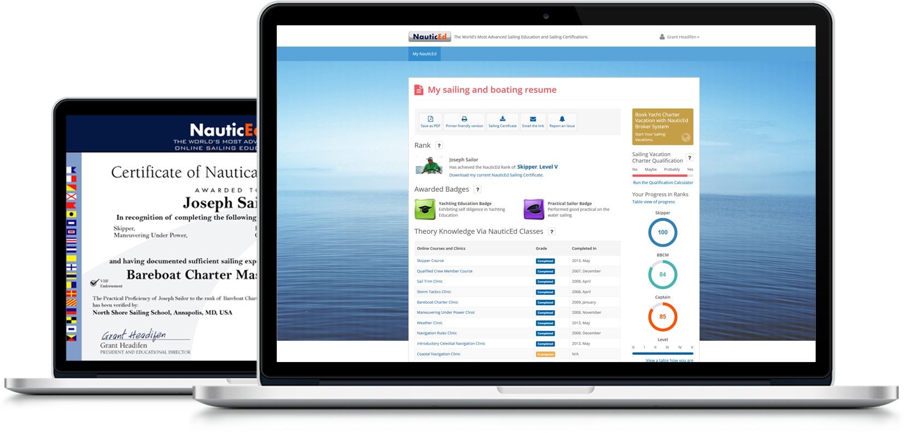
Photo Caption: NauticEd and SailTies collaborate to Authenticate Sailing Logbooks with GPS Tracking and Sharing. NauticEd offers free sailing electronic logbook and sailing resume building tools.
Social Media Post: @NauticEd and @SailTies partner to create authenticate sailing logbooks with GPS Tracking and Sharing
#sailing #sail #sailboat #yacht #yachting #yachtlife #boat #boatlife #boating #sea #ocean #nauticed #sailties #charter #bareboat #gps

Media Contacts:
Grant Headifen (NauticEd) Chris Jacobs (SailTies)
grant@nauticed.org chris@sailties.net

